A Great BIG Show
With Uncle Sam’s LITTLE Global Circus
Spontaneous Celebrations Sunday November 6th 3-9PM
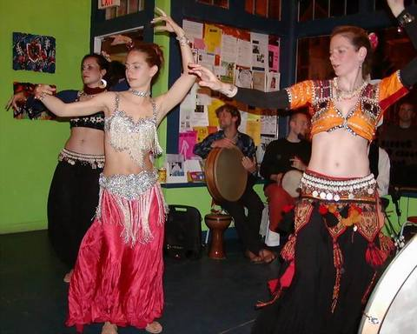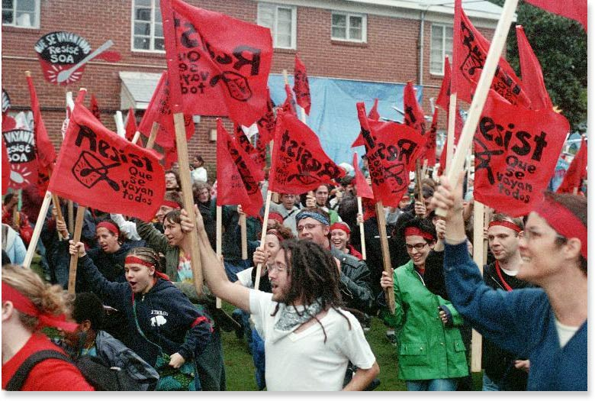
The Family Show
3-5pm
Featuring:
Clowns
Belly Dancers
Ombelico Dancers
Lillith FyerFairy Belly Dancer
Songs from around the World
With Musicians
Guy Mendilow and Jennifer Bliss

Speakers include: Gibran Rivera and the Prisoners of Conscience Fundraiser to Shut Down the Western Hemisphere Institute of Security Cooperation
The Other Show
5-9pm
Featuring:
The Walking Shoe Revival
Uncle Sam’s Little Global Circus
The Foundation
Bread and Roses
Marcio Roberto & SAMBA TREMETERRA directed by Mestre Deraldo Ferreira
AKA The School of The Americas
The SOA has trained over 60,000 Latin American soldiers in counterinsurgency techniques, sniper training, commando and psychological warfare, military intelligence and interrogation tactics. These graduates have consistently used their skills to wage a war against their own people. Hundreds of thousands of Latin Americans have been tortured, raped, assassinated, “disappeared,” massacred, and forced into refugee by those trained at the School of Assassins
Adults - $10
Youth (under 18) $5
Donations Welcomed!!

Spontaneous Celebrations
45 Danforth Street Jamaica Plain, MA 02130 (617)-524-6373
Around the Corner from
Stony Brook T
Aya@riseup.net for more info

Uncle Sam’s Little Global Circus is performance group on it’s way to Georgia to
Shut Down the SOA!

